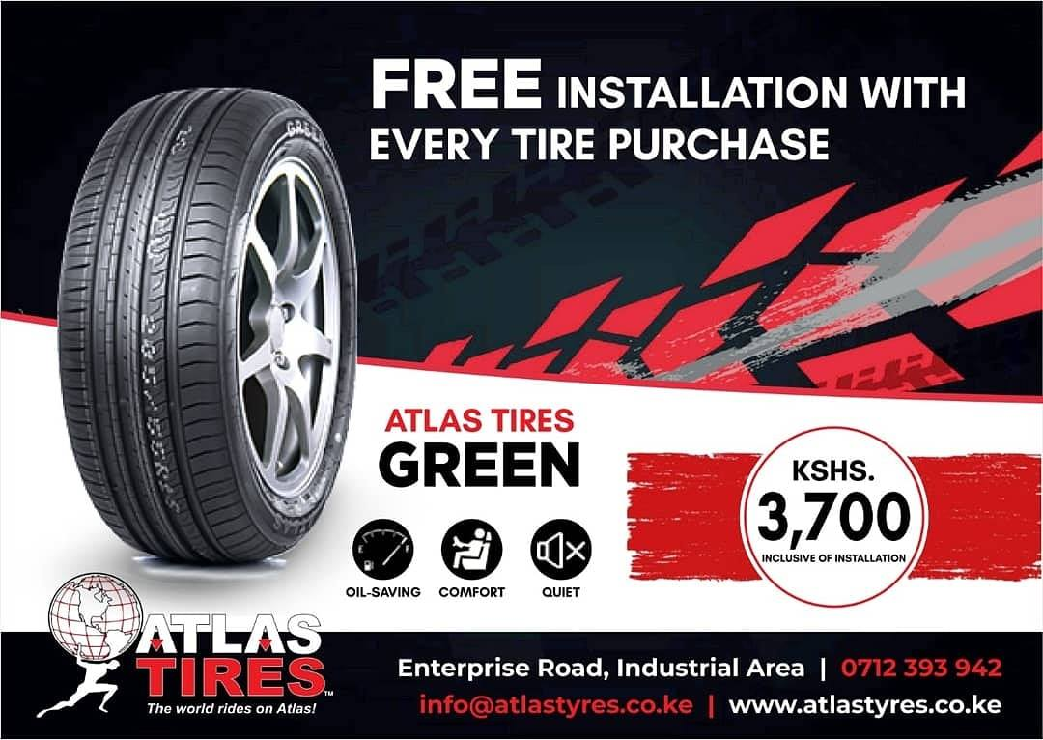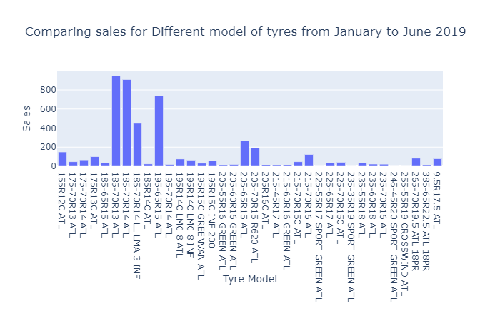

**QUESTIONS?**

* How can we increase sales?
* Which tire models are on high demand?
* Market reach?
* Band Awareness

**RESULTS**

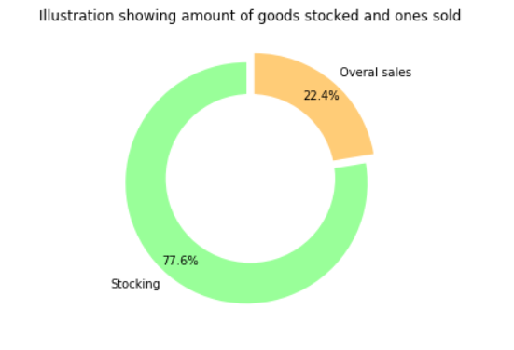

**RECOMMENDATIONS**

* Invest in marketing and increase online presence
* Stock tires based on demand. Top selling cars in Kenya currently from cheki.co.ke are Demio, fit, vits. These have a tire size of **185-65R13/14** which was there highest selling model of tire

**CHALLENGES**

* Product cycle longer than the period ATLAS TIRES have been operating

**DISCOVERIES**

* No guided way of stocking tires. **36** model of tires, only **15%** were sold in high number
* **4** models were never sold between Jan and June
* Minimum social media presence i.e Facebook only